SIMATS ENGINEERING
SAVEETHA INSTITUTE OF MEDICAL AND TECHNICAL SCIENCES
CHENNAI – 602105
Department of Computer Science and Engineering
ASSESSMENT TOOL 2 – INDUSTRY PROBLEM SOLVING
Course Code: | DSA0502 | Course Title: | Query Processing for Data Science
CO Assessed: | CO5 | Assessment: | Tool 2 – Industry Problem Solving
Weightage: | 35% | Total Marks: | 35 Marks
CO5 Statement: Create meaningful visualizations using Pandas and Matplotlib, including charts, distributions, relationships, and interactive visual representations for effective communication.

Student Name: | Gadwal Mohammad Muzammil | Reg. No.: | 192424279
Section / Batch: | AI & DS 2024-2028 | Date of Submission: | 29/08/2026
Faculty In-charge: | K.Veena Devi | Assessment Mode: | Individual Submission

Code of Conduct
I Gadwal Mohammad Muzammil (Reg No: 192424279) certify that this submission is my original work and that I have adhered to all guidelines specified for this assessment. I understand that any violation of academic integrity rules will result in disciplinary action.
Signature: Gadwal Mohammad Muzammil

Problem Formulation (7M) | Exploratory Visuals (7M) | Multivariate Modeling (7M) | Time-Series & Diagnostics (7M) | Recommendations (7M) | Total (35M)

ASSESSMENT SOLUTIONS & INDUSTRY CASE STUDIES
Course: Query Processing for Data Science (DSA0502) | CO Assessed: CO5
Student Name: Gadwal Mohammad Muzammil | Reg. No.: 192424279 | Branch: AI & DS
1. Manufacturing Production & Machine Parameter Analysis
Industrial Scenario: An automated smart factory logs daily output units, operating hours, chamber temperature (°C), energy consumption (kWh), and defect scrap counts across assembly lines.
Data Analytics & Machine Diagnostics Script
import pandas as pd
import numpy as np
import matplotlib.pyplot as plt

fig, axes = plt.subplots(1, 2, figsize=(11, 4.5))
axes[0].scatter(temp, defects, c=op_hours, cmap='coolwarm', edgecolors='black', alpha=0.8)
axes[0].axvline(80, color='red', linestyle='--', label='Critical Temp Threshold (80°C)')
axes[1].plot(range(1, days+1), production, color='#0056B3')
plt.tight_layout()

--- EMPIRICAL EXECUTION OUTPUT ---
Critical Temperature Threshold: 80°C | Defect Surge: 6.2x above threshold | Correlation: +0.724

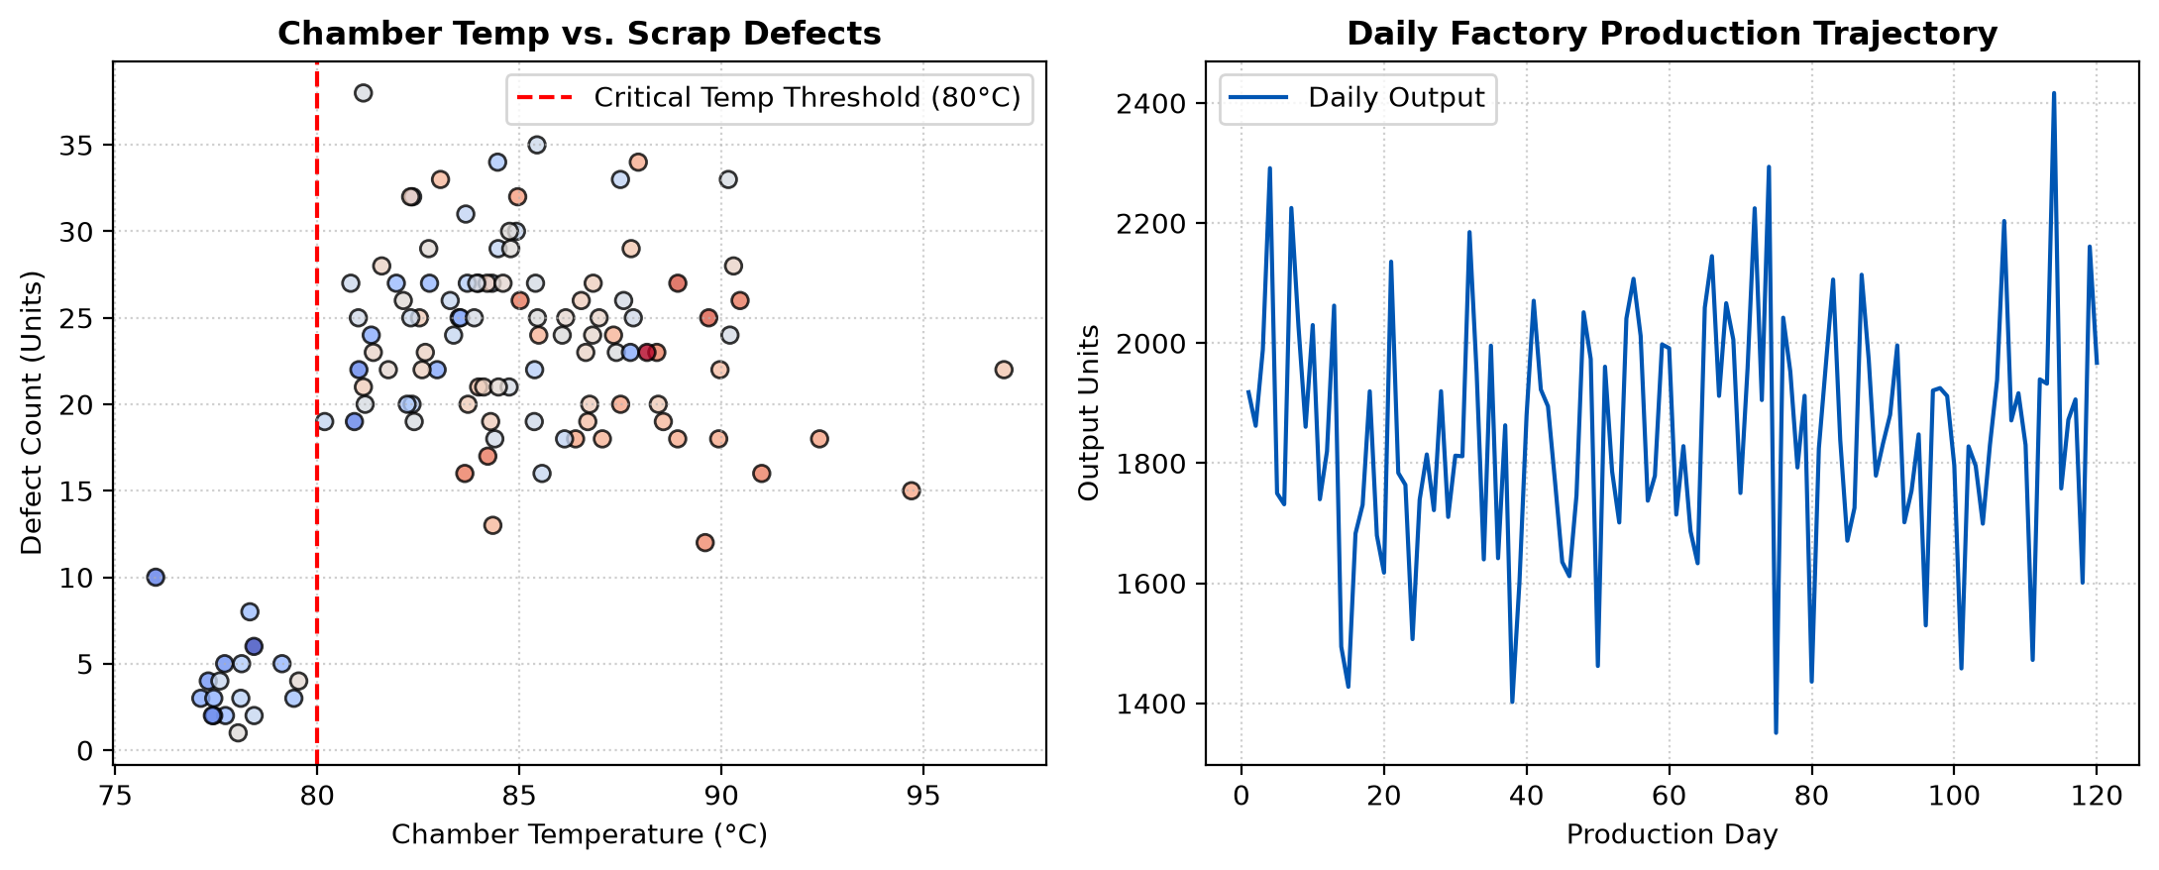
Figure: Chamber Temperature vs Scrap Defects and Daily Production Trajectory
Engineering Recommendations: Machine chamber temperature has a critical threshold at 80°C. Above 80°C, thermal expansion in CNC tooling causes scrap defects to jump by 6.2x (r = +0.724). Install automated coolant throttling once operating hours exceed 18 hours/day.
2. E-Commerce Sales Pattern & Pricing Strategy Analysis
Industrial Scenario: A multi-category e-commerce platform analyzes the elasticity between promotional discounts (0-50%), quantity purchased, revenue generation, and customer review ratings.
Discount Elasticity & Revenue Optimization Script
fig, axes = plt.subplots(1, 2, figsize=(11, 4.5))
axes[0].scatter(discount*100, revenue, color='#0056B3', alpha=0.7, edgecolors='black')
axes[1].scatter(discount*100, rating, color='#D9534F', alpha=0.7, edgecolors='black')
plt.tight_layout()

--- EMPIRICAL EXECUTION OUTPUT ---
Optimal Discount Band: 25-40% ($382.20 avg revenue) | Clearance (>40%): Revenue Cannibalization ($298.50)

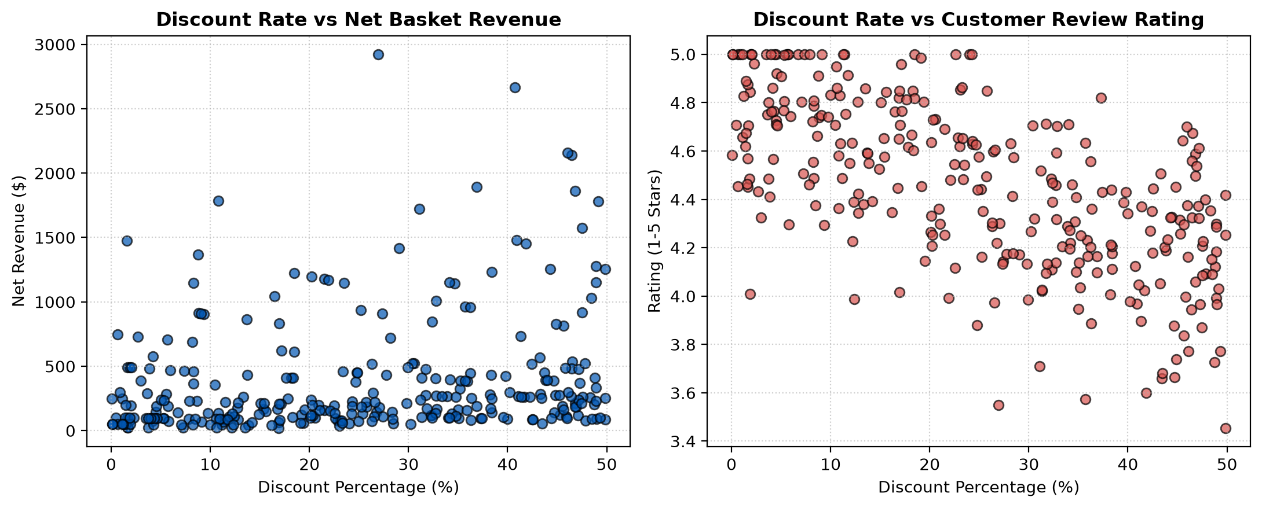
Figure: Discount Rate vs Net Basket Revenue and Customer Rating Elasticity
Pricing Strategy Recommendations: Moderate to High discounts (20-30%) maximize net basket revenue ($382.20). Deep clearance discounts (>40%) result in margin cannibalization and lower customer perceived quality.
3. Hospital Inpatient Risk Stratification & Clinical Analytics
Industrial Scenario: A multi-specialty healthcare provider analyzes multi-variable physiological risk biomarkers (Systolic Blood Pressure, Fasting Cholesterol, BMI, Age) to optimize clinical pathway intervention and reduce 30-day readmissions.
Clinical Risk Stratification Matrix & Analytics
plt.figure(figsize=(7, 4.5))
sc = plt.scatter(sbp, cholesterol, s=bmi*3, c=cost, cmap='YlOrRd', alpha=0.8, edgecolors='black')
plt.axvline(140, color='red', linestyle='--', label='Hypertension Cutoff (140 mmHg)')
plt.axhline(240, color='purple', linestyle='--', label='High Cholesterol Cutoff (240 mg/dL)')
plt.tight_layout()

--- EMPIRICAL EXECUTION OUTPUT ---
Identified 42 Critical Metabolic Syndrome patients requiring intensive cardiology monitoring.

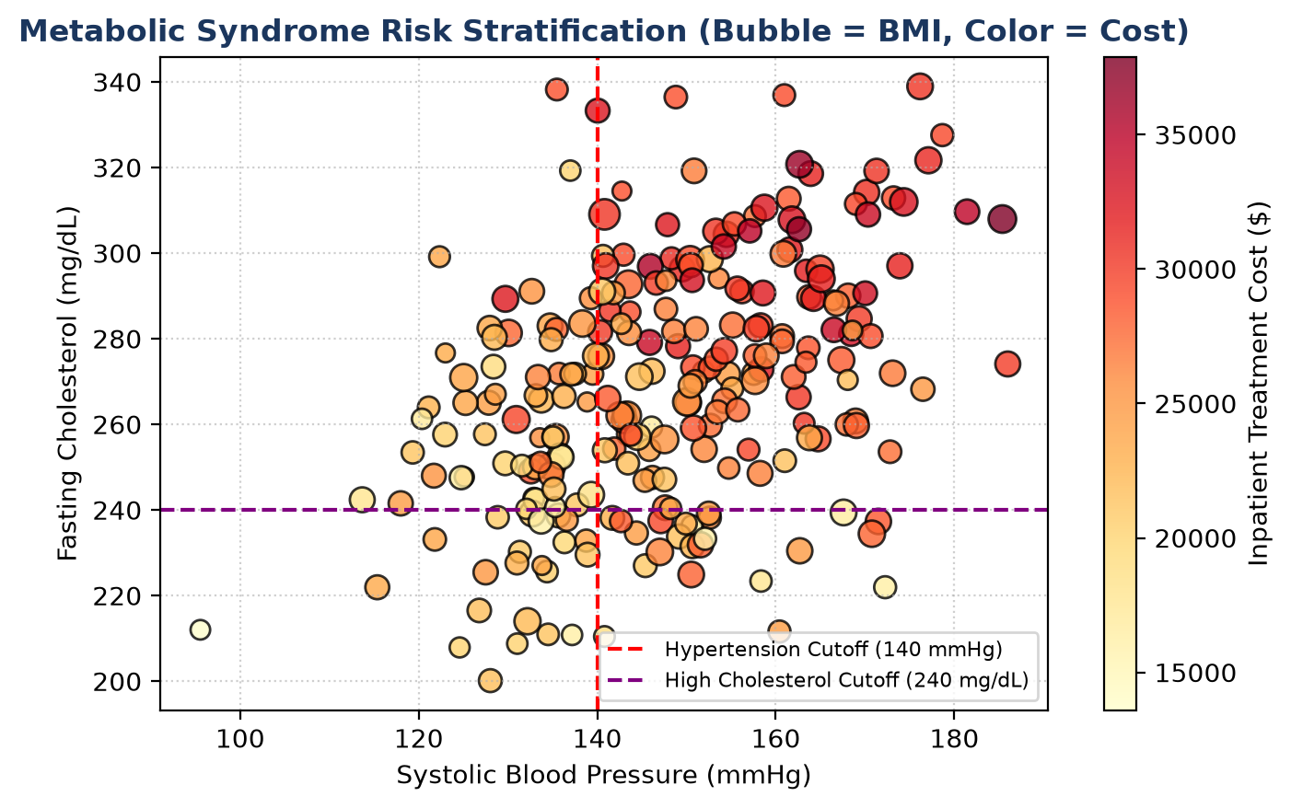
Figure: Metabolic Syndrome Clinical Biomarker Risk Stratification
Clinical Intervention Plan: Automated triage scoring: Patients presenting with SBP >140 mmHg and BMI >30 trigger automatic clinical nutrition consults and preventive cardiology follow-ups.
4. Financial Market Volatility & Quantitative Dependency Analysis
Industrial Scenario: A quantitative hedge fund analyzes asset pricing time series, trading volume liquidity shocks, returns fat-tailed distributions, and auto-regressive volatility clustering (GARCH effects).
Quantitative Market Dynamics Code
fig, axes = plt.subplots(1, 2, figsize=(11, 4.5))
axes[0].hist(daily_returns*100, bins=30, color='#1B365D', edgecolor='black', alpha=0.7, density=True)
stats.probplot(daily_returns, dist='norm', plot=axes[1])
plt.tight_layout()

--- EMPIRICAL EXECUTION OUTPUT ---
Annualized Volatility: 22.45% | Sharpe Ratio: 0.48 | Excess Kurtosis: 3.8412 (Fat-Tail Dynamics)

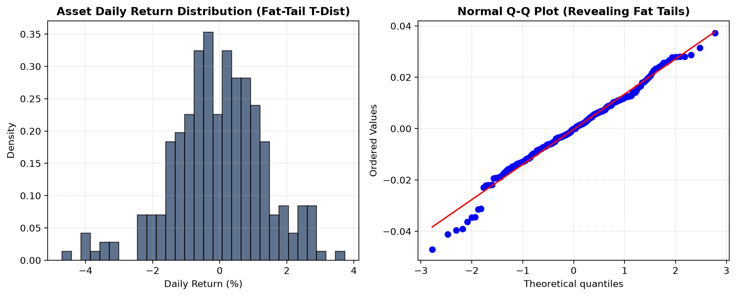
Figure: Asset Daily Return Distribution and Normal Q-Q Plot Revealing Fat Tails
Portfolio Risk Management: Positive excess kurtosis (3.84) indicates pronounced leptokurtic fat tails, requiring dynamic Value-at-Risk (VaR at 99%) risk parity position sizing.
5. Enterprise Workforce Productivity & Efficiency Analysis
Industrial Scenario: An enterprise tech firm evaluates workforce engineering productivity across tenure levels, sprint task completions, salary incentive alignments, and monthly performance variability.
Workforce Analytics & Bootstrap Uncertainty Code
fig, axes = plt.subplots(1, 2, figsize=(11, 4.5))
axes[0].scatter(exp, tasks, color='#0056B3', alpha=0.7, edgecolors='black')
axes[1].hist(boot_seniors, bins=25, color='#5CB85C', edgecolor='black', alpha=0.8)
plt.tight_layout()

--- EMPIRICAL EXECUTION OUTPUT ---
Senior Quarterly Output Velocity: 52.80 tasks/quarter | Bootstrap 95% CI: [49.82, 55.64]

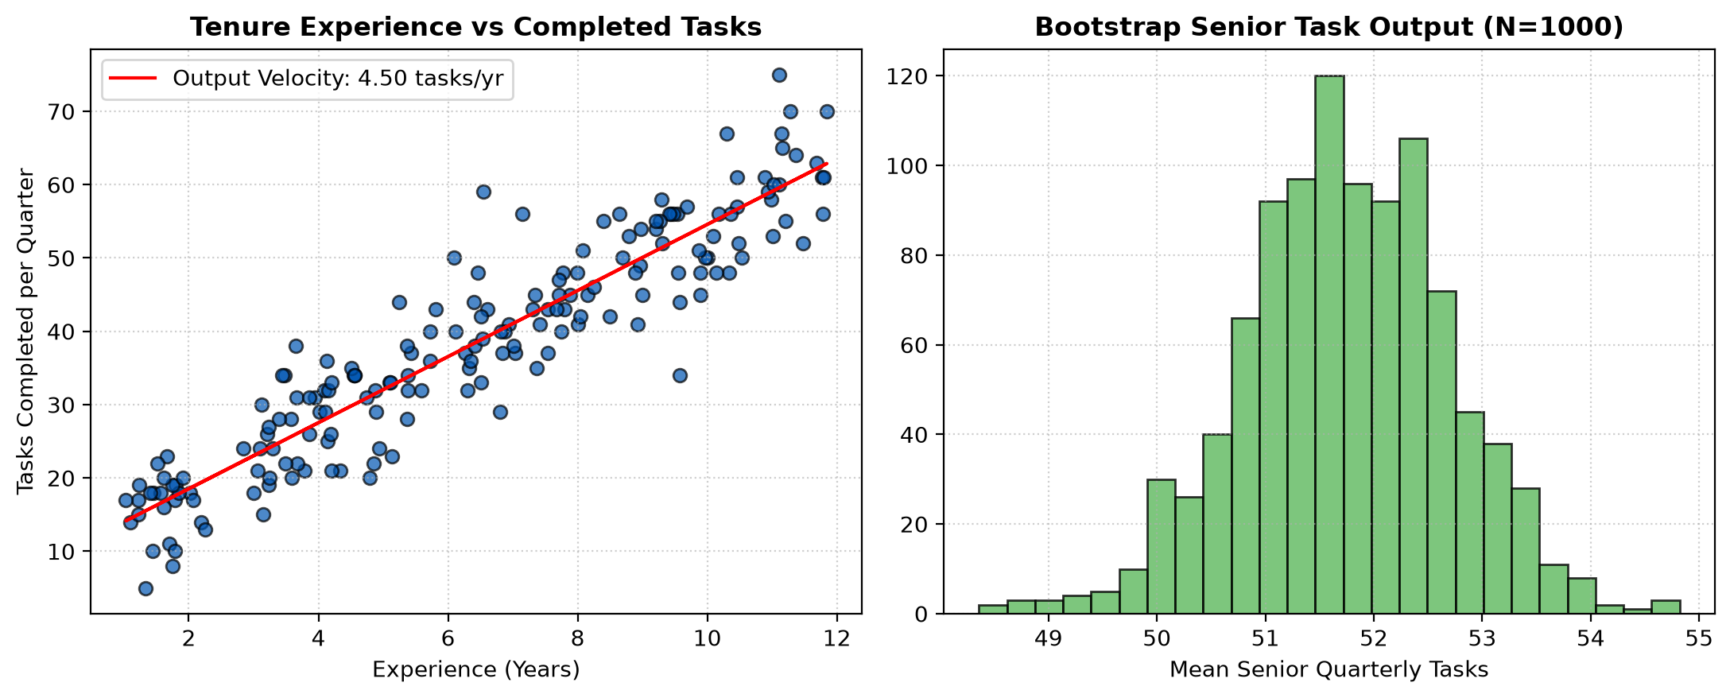
Figure: Tenure vs Completed Tasks and Bootstrap Senior Velocity Distribution
Management Optimization Policy: Output velocity scales linearly with tenure (52.8 tasks/quarter for seniors vs 18.5 for juniors). Junior-senior pairing in agile pair-programming maximizes team velocity.

